platezhka.config

true
false

<SelectedValidator>JCM</SelectedValidator>

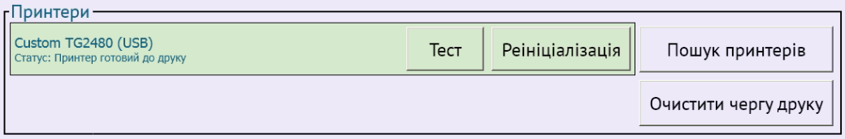

Пристрої
Принтер

<Type>Custom</Type>
<Port>USB</Port>

<Type>WindowsPrinter</Type>
<Name>CUSTOM TG2480-H</Name>

<PrintAsImage>true</PrintAsImage>

<CharSize>8</CharSize>

<CutAfterPrint>false</CutAfterPrint>

<UseCommands>false</UseCommands>

<UsePrinterManager>true</UsePrinterManager>

Мережа

<ConnectionTimeout>PT7M</ConnectionTimeout>

<RetryCount>20</RetryCount>

<Brand>Kyivstar</Brand>

<PriorityCheckFrequency>500</PriorityCheckFrequency>

<IsConfiguredManually>true</IsConfiguredManually>

<InterfaceSettings>
<NetworkInterfaceSetting>
<Name>Realtek PCIe GBE Family Controller #2</Name>
<Priority>1</Priority>
</NetworkInterfaceSetting>
</InterfaceSettings>
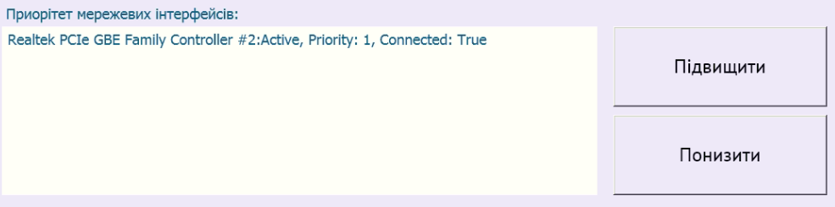

<EnableModemReset>true</EnableModemReset>

<UseBiosRestart>true</UseBiosRestart>

<UseNfcReader>false</UseNfcReader>

<UsePosTerminal>false</UsePosTerminal>

<EnableAutoSettlement> true </EnableAutoSettlement>
<EnablePosLogs>true</EnablePosLogs>

<DispenserPort>COM1</DispenserPort>
<DispenserType>CVD</DispenserType>

<BarcodeReaderPort>COM1</BarcodeReaderPort>

<UseCoinAcceptor>false</UseCoinAcceptor>

Налаштування
Головні налаштування

<AdvertisementPlayerEnabled>true</AdvertisementPlayerEnabled>
<SecondMonitorPosition>Bottom</SecondMonitorPosition>

<ShowMousePointer>true</ShowMousePointer>

<UseSlimIfNotAccelerated>true</UseSlimIfNotAccelerated>

<Skin>TAC</Skin>

<EncashCheckCount>2</EncashCheckCount>

<EncashmentCheckType>Default</EncashmentCheckType>

<EncashmentCheckPrintAsImage>false</EncashmentCheckPrintAsImage>

<MainMonitorPosition>Top</MainMonitorPosition>

<RebootTimeout>30</RebootTimeout>

<UseHibernationRestart>false</UseHibernationRestart>

<HibernationRestartTimeout>15</HibernationRestartTimeout>

<UseBiosRestart> true </UseBiosRestart>

<BiosRestartTimeout>15</BiosRestartTimeout>

<BiosRestartMinutesTimespan>415</BiosRestartMinutesTimespan>
415=6*60+55

Задачі

<EventType>Shutdown</EventType>
<EventStartType>JustInTime</EventStartType>
<BeginTime>0</BeginTime>
<EndTime>0</EndTime>
<IsEnabled>false</IsEnabled>

<EventType>Suspend</EventType>
<EventStartType>Interval</EventStartType>
<BeginTime>0</BeginTime>
<EndTime>0</EndTime>
<IsEnabled>false</IsEnabled>

<EventType>Hibernate</EventType>
<EventStartType>Interval</EventStartType>
<BeginTime>0</BeginTime>
<EndTime>0</EndTime>
<IsEnabled>false</IsEnabled>

<EventType>LowMemory</EventType>
<EventStartType>Periodical</EventStartType>
<BeginTime>0</BeginTime>
<EndTime>0</EndTime>
<IsEnabled>false</IsEnabled>
<Options />

<EventType>ScreenTurnOff</EventType>
<EventStartType>Interval</EventStartType>
<BeginTime>0</BeginTime>
<EndTime>0</EndTime>
<IsEnabled>false</IsEnabled>

<EventType>RebootOnNoClick</EventType>
<EventStartType>Interval</EventStartType>
<BeginTime>0</BeginTime>
<EndTime>0</EndTime>
<IsEnabled>false</IsEnabled>
<Options />

Платежі

<NotSendPaymentsLimit>5</NotSendPaymentsLimit>
<WorkWithoutPrinter>true</WorkWithoutPrinter>

<CasetteCapacity>1000</CasetteCapacity>

<AllowWorkWithOutValidator>false</AllowWorkWithOutValidator>

<SecureMode>false</SecureMode>

